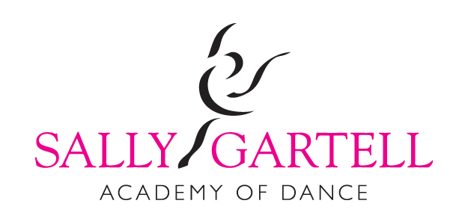
Please note classes will be running on Bank Holiday Monday 1st May
Examinations
We had some fantastic exam results in December & February well done to everyone who worked so hard to achieve these fabulous results.
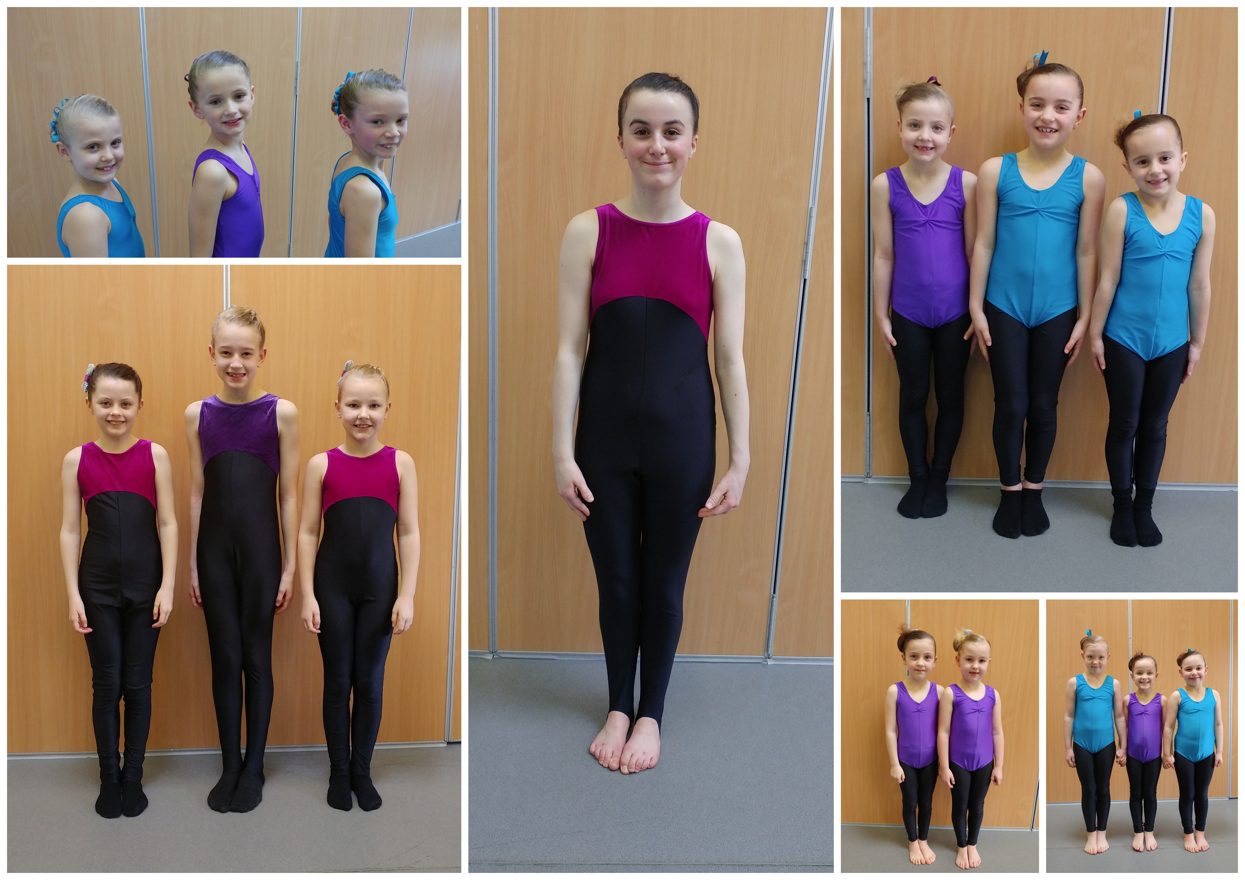
Our next exam session will be October 29th or 30th.
Exams aren't for every child and I would like to remind you all that they are not compulsory. I want children to come to my school because they enjoy dancing and would like to learn a skill that will stay with them forever.
When you commit to doing the exam you must attend all classes and extra coaching sessions so that your child has every opportunity to achieve their very best.
Please see website for more details on examinations.
Theatre Trips
We had a very enjoyable trip to see Billy Elliot at the beginning of April our next trip is to see Grease on Monday 29th May (fully booked) leaving the Sun inn Marton at 5pm so please arrive by 4.45 we will arrive back around 11.30pm
Our 2018 trip is to see the amazing 'Wicked' which is the Prequel to the wizard of Oz telling the story of how the wicked witch became wicked!

When …. Thursday April 5th 2018 2pm Performance
Cost …. £47 which includes coach

Performance Workshop
On January 8th we performed for the senior citizens Christmas party.
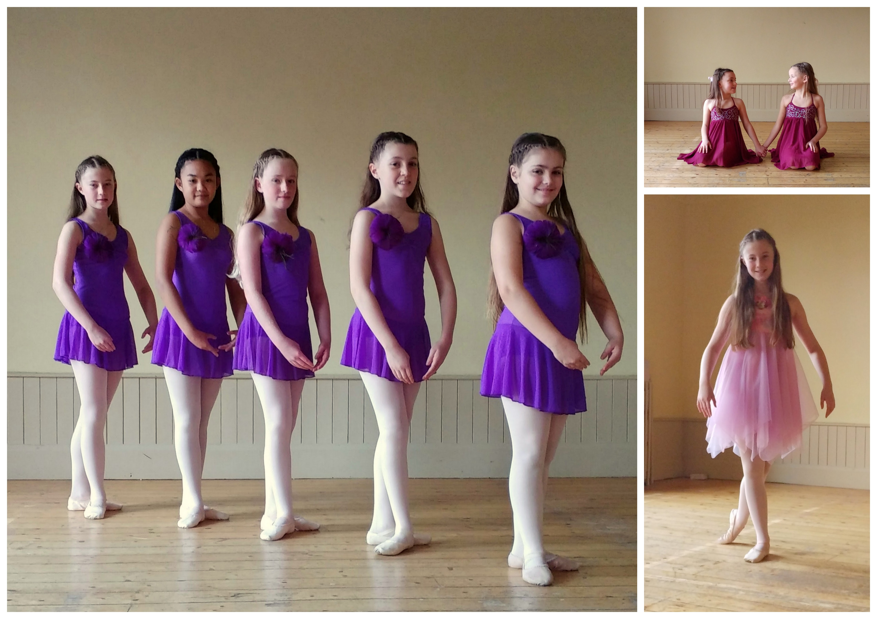
.
Performance Workshop is a fun hour long class where we learn routines that we perform at events and hopefully in the future take to competitions. Students are invited to performance workshop classes if they attend a minimum of two syllabus classes of different genres a week. We dip into many different styles of dance and students need to be able to pick up choreography quite quickly. If this is something your child would be interested in please let me know. At the moment the class is for children 9+ but I'm looking to start a younger class in the near future.
Uniform
Some students have been looking a little less than smart of late!
Please ensure your child has the correct uniform for class and hair is tied up at all times, buns are preferable for all classes as it keeps hair off the neck and face and presents an ideal appearance for dance, if you're unsure of how to do the perfect ballet bun pop over to my website where you can find a video tutorial.
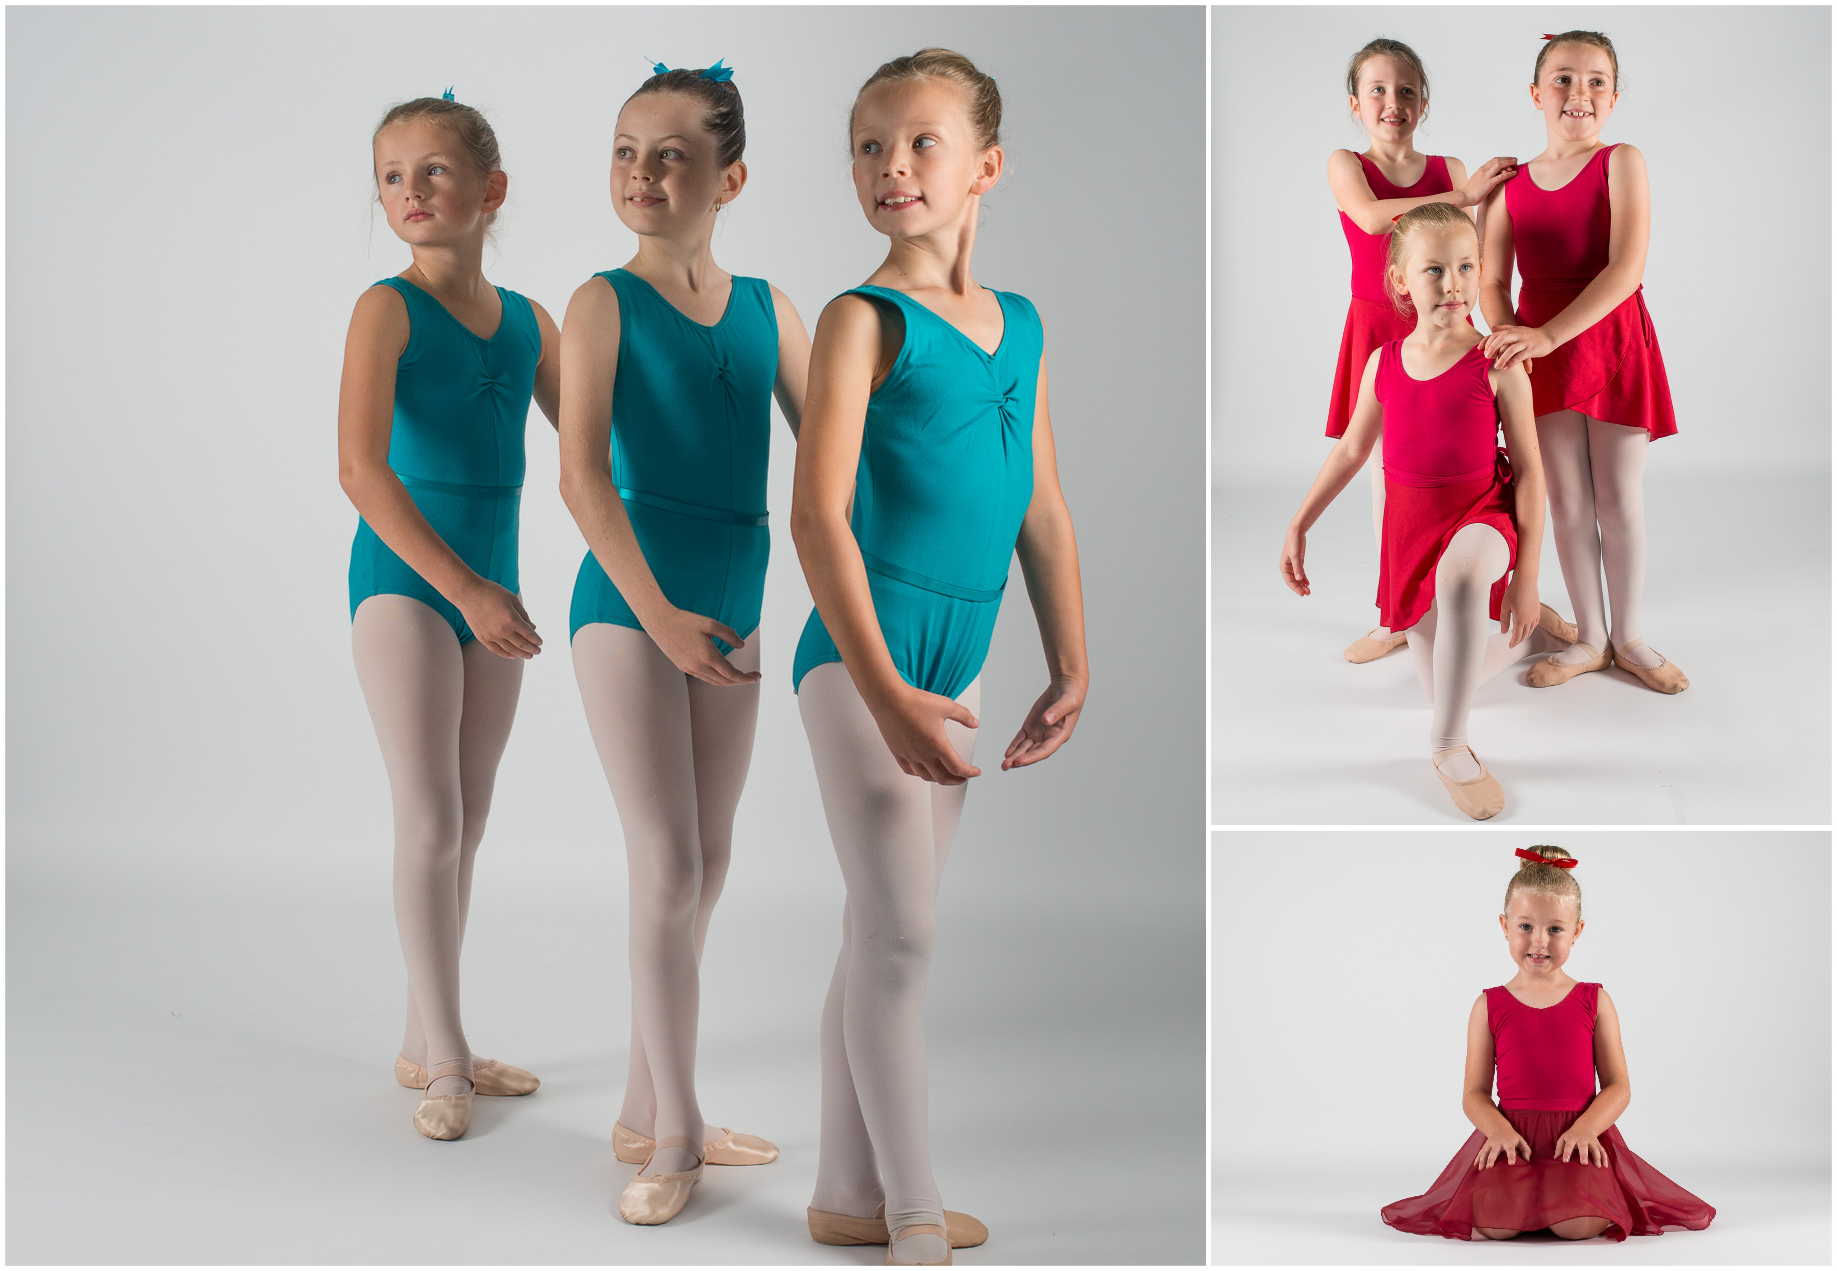
Uniform can be ordered through myself at very competitive prices all uniform requirements can be found on the website.

Adult Classes
It's not just children who love to dance!
I hold several different classes for adults too. There are Ballet classes on a Tuesday 1-2pm & Wednesday 8-9pm & Tap classes Tuesday 8-9 & Thursday 8-9 all held in Montgomery. Its a good form of exercise as well as a great way of meeting new friends whilst having fun.
Fees, Payments & Terms & Conditions
Fees need to be paid within the first two weeks of term. After this period a late payment fee of £5 will be added.
I prefer fees to be paid by bank transfer but I am happy to accept cash or cheque as long as it is clearly named.
Payment for uniform needs to be made at time of ordering.
If you wish to cease classes half a terms notice or fees in lieu need to be given.
Website & Facebook
Keep up to date with all that's going on with either the website www.sallygartell.com
or facebook page www.facebook.com/sallygartellacademyofdance.
These are both refreshed regularly with dates and events also lots of lovely pictures and videos
Dates For Your Diary

- Monday 29th May ….... Grease Theatre Trip
- Saturday 1st July …... Montgomery Street Fair
- Friday 21st July …... Last Day of Term
- 14th-18th August …... Summer holiday classes
- Saturday 19th August …... Montgomery Show
- Monday 4th September …... Classes resume
- Sunday 29th October …... Ballet Exams
- Monday 30th October …... Reserve Exam day
- Sunday 19th November …... Tapathon 2017

