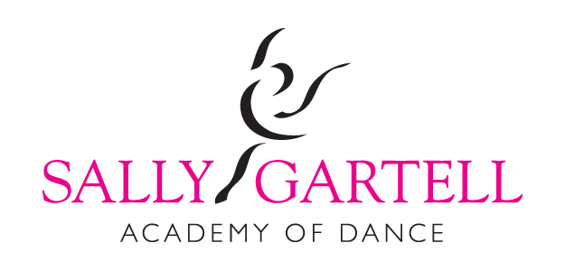

Exam Coaching 2019
All coaching lessons are held at Montgomery Activity Centre
Grade 2 Modern | Friday 15th Feb  3.40 – 4.20 | Friday 22nd Feb  3.40 – 4.20
Grade 4 Modern | Saturday 9th Feb  1.00-2.00 | Saturday 16th Feb  1.00-2.00 | Saturday 23rd Feb  1.00-2.00
Grade 1 Tap | Saturday 16th Feb  2.00-2.40 | Saturday 23rd Feb  2.00-2.40
Grade 2 Tap | Saturday 16th Feb  2.40 – 3.20 | Saturday 23rd Feb  2.40 – 3.20
Primary Tap | Sunday 10th Feb  1.00-1.40 | Sunday 17th Feb  1.00-1.40
Grade 1 Modern | Sunday 10th Feb  1.40-2.20 | Sunday 17th Feb  1.40 -2.20
Grade 3 Tap | Sunday 10th Feb  2.20 – 3.00 | Sunday 17th Feb  2.20 – 3.00

It is essential all these coaching lessons are attended as we go over important exam settings that wouldn’t be done in normal class times.
As well as the exam coaching lessons I do encourage you to attend any alternative timetabled class.
Please see timetable for days and times www.sallygartell.com.

